|  |
| --- |
| Circle Language Spec: Inheritance |

## Extending the System Objects in a Diagram

The concept of extending the system objects is already explained in the article *Extending the System Objects*. The current article demonstrates its expression in a diagram.

Not all possible extensions of the system commands will be displayed in this article. Any extension procedure of the system interface commands is displayed the same way. Only a couple of extension procedures will be displayed, to demonstrate the idea.

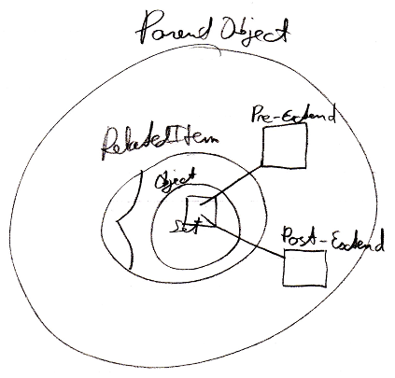

In the picture above, a Related Item is shown inside a Parent Object. The system interface of the related item is opened up. You can see the Object part of the system interface. Inside the Object part of the system interface is displayed the Object . Set command. Lines are going out of the Object . Set command to the Pre-Extend and Post-Extend procedures, that are implemented by the Parent Object.

Extension of system commands of a related list item works a bit differently, because the extension procedures of a related list item are the same for all items in the list, thus the extension procedures are defined by the related list. The related list defines a number of objects, that contain references to the extension procedures. When you open up the system interface of a related list, you can specify the extension procedures.

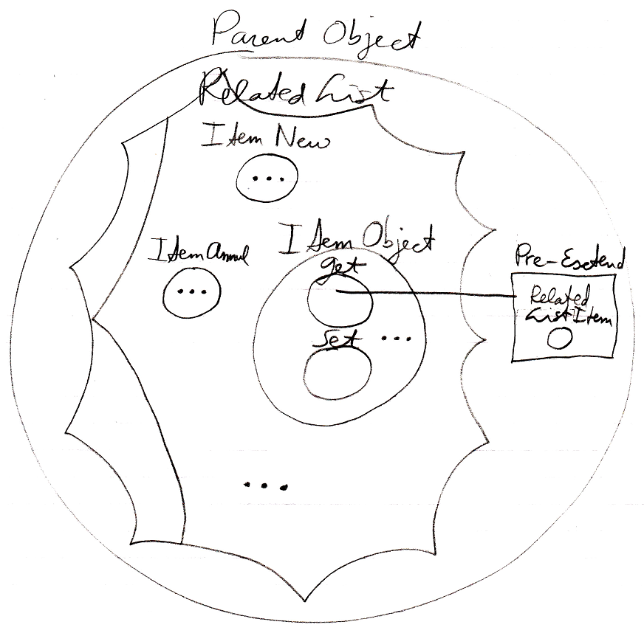

The examples shows the system interface of a related list, but not all its members. The following system objects are shown: Item New, Item Annul and Item Object. The rest of the system objects are left out. The system object Item Object contains the Get and Set objects. Objects like Item Object . Get, that have the same name as a system command of a related list item, define the extension procedures. In the example above, the system object Item Object . Get has a pre- extension defined. The extension is displayed as a line going out of Item Object . Get to a procedure named Pre-Extend, defined inside the parent object. The extension procedure is passed a parameter, namely: the Related List Item for which the extension procedure was callled.